|  |  |
| --- | --- |
|  | FPT ACADEMY INTERNATIONAL  FPT – APTECH COMPUTER EDUCATION |

Centre Name: ACE-HCMC-2-FPT

Address: 590 Cach Mang Thang 8, District 3, Ho Chi Minh City, Viet Nam.

**Aptitude Online Test**

|  |  |  |
| --- | --- | --- |
| Supervisor: | Dinh Vu Quoc Trung | |
| Semester: | Semester 3 | |
| Batch No: | T1.1707.E0 | |
| Group No: | Group 6 | |
| Order: | Full name | Roll No. |
| 1. | To Nguyen Thien Chi | Student1040277 |
| 2. | Nguyen Huu Dam | Student1032633 |
| 3. | Dinh Hoang Quan | Student1048374 |

*Month 10 Year 2018*

**Table of Contents**

I. Acknowledgement: 5

II. Problem Definition: 5

1. Introduction 5

2. Problem Definition 5

*2.1 Problem Abstraction* 5

*2.2 Customer Requirement* 6

*3.1 Hardware/ Software Requirements* 7

III. Task sheet review 1 7

IV. Architecture & Design of the Project 8

1. Presentation Tier: 8

2. Business Logic Tier: 8

3. Data Access Tier: 8

V. Algorithms - Data Flowchart: 9

*1. Main data flow for candidate.* 9

*2. Main data flow for manager.* 9

*3. View record* 9

4. Add new record 9

*VI. Data Flow Diagram:* 10

1. Level 0 Data Flow Diagram 11

2. Level 1 Data Flow Diagram 12

*2.1. Administrator Manage Users* 12

*2.2. Manager Manage Candidates Information* 12

*2.3. Manager Manage Exam Registrations* 13

*2.4. Manager Manage Schedule* 13

*2.5. Manager Manage Exam Result* 14

*2.6. Manager Manage Questions* 14

*2.7. Manager Manage Questions Type* 14

*2.8. Candidate Manage Candidates Information* 14

*2.9. Candidate Manage Test Registrations* 15

*2.10. Candidate Manage Schedules* 15

*2.11. Candidate Manage Test Result* 16

VII. Use Case Diagram: 16

*1. Administrator Use Case* 16

2. Manager Use Case 17

3. Candidate Use Case 18

VIII. Sequence Diagram: 18

*1.* *Create User* 18

*2.* *Update/Disable User* 19

*3.* *View User* 20

*4.* *Login:* 22

*5.* *Logout:* 23

*6.* *Change password* 24

*7.* *Register user candidates* 25

*8.* *Manager register user candidates* 26

*9.* *Manage questions* 27

*10.* *Manage schedule* 28

*11.* *Manage exam* 29

*12.* *Manage test results* 30

*13.* *View the schedule* 31

*14.* *View results* 32

*15.* *Perform test* 33

IX. Entity–Relationship Design: 34

*1. Entity–Relationship Diagram* 34

2. Entities and Properties 35

*2.1. User Role Entity & Properties* 35

*2.4 Schedule Entity & Properties* 37

*2.5 Exam Entity & Properties* 37

*2.6 Details Exam Entity & Properties* 38

*2.7 Question Entity & Properties* 38

*2.8 Type Of Question Entity & Properties* 39

X. Task sheet review 2 40

# I. Acknowledgement:

We would like to acknowledge all those who have given support and help us make the project a success.

We wish to express our deep gratitude to all teachers who have been devoting their lives to teach us how to stand-alone and walk ahead.

We are grateful to our families who take care and encourage us even though we are successful or failed, also to our friends who are always care of us. They never leave us alone and always look forward to us when we are on any road of the life.

We are much thankful to the entire staff and chairpersons at the Head Office of Aptech Worldwide, Aptech – Vietnam, and FPT – Aptech Center who have been organizing and looking after our studying course.

There are no words to show our appreciation for teachers of FPT Aptech Centre who have been organizing and looking after us during our studying course to finish this project.

Finally, we would like to offer many thanks to all our schoolfellows for their valuable suggestions.

We would like to thank sincerely!

# II. Problem Definition:

## 1. Introduction

(Aptitude test online) helps organizations develop innovative business and commerce strategies and solutions. These solutions allow their customers to capitalize on new technologies to create innovative products and services for the economy. Their consulting team stays focused on defining, optimizing, and aligning their client’s business and IT strategies.

## 2. Problem Definition

### *2.1 Problem Abstraction*

The Webster organization is the leading organization in the world of Oil-Gas Company. They have various branches throughout the world. It has various bonds with different multi-national company. The company wants an application to be built for the jobseeker where the entire candidate as per to the criteria will appear for the online test and based on the result of this the candidate will go for further rounds. So they had approached us in order to help them by creating a web application for them meeting their requirements.

### *2.2 Customer Requirement*

Client has put forwarded all the list of data’s, he/she required in the application which is stated below:

* MANAGER: Manager will have the authority to enter the details of the candidates appearing for the interview. Details to be maintained like Education details, Personal details, Work Experience. After this Manager will allocate the Username and Password for the candidates.
* Manager can even view the list of all the candidate who is or has appeared along with the result (if achieved)
* If the candidate passes the test, then their names are transferred for next round (HR) round. In the transfer process the data of the candidate must be transferred in the new table (Transfer/ Apti-clear Table) which will be referred by the concern person.
* Manager even will have the responsibility to edit, update, add, save the test question. For doing this the manager has go in the test section available on its profile and can change the question accordingly by clicking the edit button and then saving the new question.
* Report section must be added for viewing the generalized data which can be filter by date, week or month.
* CANDIDATE LOGIN: Each candidate will have their login details provided to them by the Manager. These details must be entered in the candidate’s login section.
* Candidate will start the test then as per the schedule, time allocated for the test. They are supposed to follow the linear mode and once the answer is submitted then it can be changed.
* After finishing the test the candidate will have to click on “Complete my test” and then log out the session.

### *3.1 Hardware/ Software Requirements*

|  |  |  |  |
| --- | --- | --- | --- |
|  | Server | Client | Developer tools |
| Hardware | * Ram 16 GB or larger  * CPU 4.0 Ghz or larger  * HDD 1 TB or larger  * Connect to internet | * Ram 4 Gb or larger  * CPU 1.0 Ghz or larger  * Connect to internet | * Ram 4 Gb or larger  * CPU 2.0 Ghz or larger  * Connect to internet |
| Software | * Microsoft Windows 7 or later  * SQL Server 2017  * IIS 6 or later | * Internet Explorer  * Firefox  * Chrome  * Safari | Microsoft Windows 7  Microsoft Visual Studio 2017  Net Framework 4.6.1 |

# III. Task sheet review 1

|  |  |  |  |  |
| --- | --- | --- | --- | --- |
| No. | Description | Begin Date | TeamMate Name | Notes |
| 1 | Problem abstraction | 06/10/2018 | All member |  |
| 2 | Customer Requirement | All member |  |
| 3 | Hardware/Software Requirement | All member |  |
| 4 | Task sheet | All member |  |
| 5 |  |  |  |
| 6 |  |  |  |
|  |  |  |  |  |

|  |  |
| --- | --- |
| Date: | |
| **Signature of Instructor:**  **Dinh Vu Quoc Trung** | **Signature of Team Leader:**  **To Nguyen Thien Chi** |

# IV. Architecture & Design of the Project

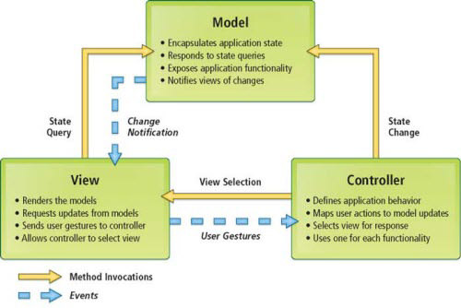

## 1. Presentation Tier:

Is the tier in which the users interact with application . Presentation Tier contents Model, View, Controller used to receive a request and response to User.

Technology: ASP.NET MVC5, HTML, CSS, JavaScript, Ajax, JQUERY, Bootstrap

## 2. Business Logic Tier:

Is mainly working as the bridge between Data Tier and Presentation Tier. All the Data passes through the Business Tier before passing to the Presentation Tier.

Technology: OOP, ASP.NET

## 3. Data Access Tier:

Is basically the server which stores all the application’s data .Data tier contents Database Tables, Database Views and other means of storing Application Data .

Technology: SQL Server, LINQ, ADO.NET

# V. Algorithms - Data Flowchart:

**Symbol generates:**

***1. Main data flow for candidate.***

***2. Main data flow for manager.***

***3. View record***

## 4. Add new record

***5. Edit record***

# *VI. Data Flow Diagram:*

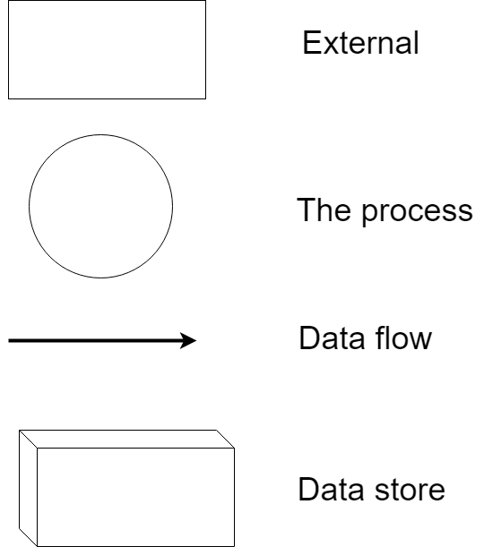

## 1. Level 0 Data Flow Diagram

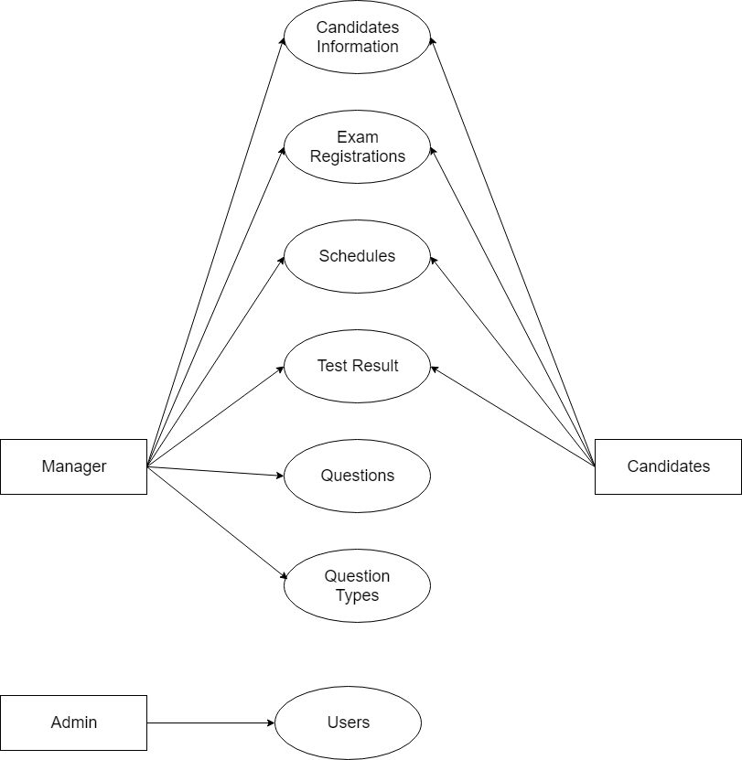

## 2. Level 1 Data Flow Diagram

*2.1. Administrator Manage Users*

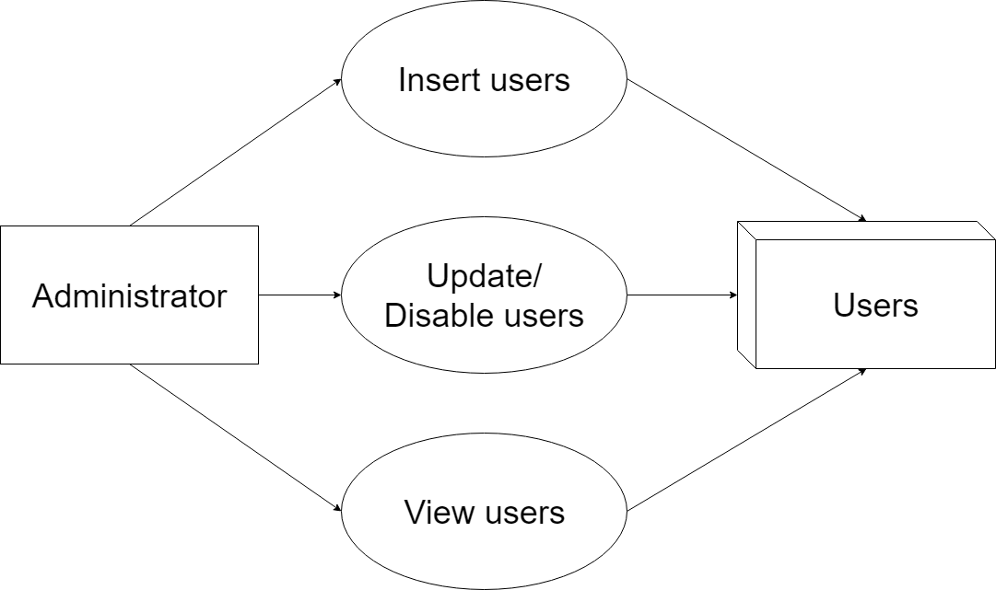

*2.2. Manager Manage Candidates Information*

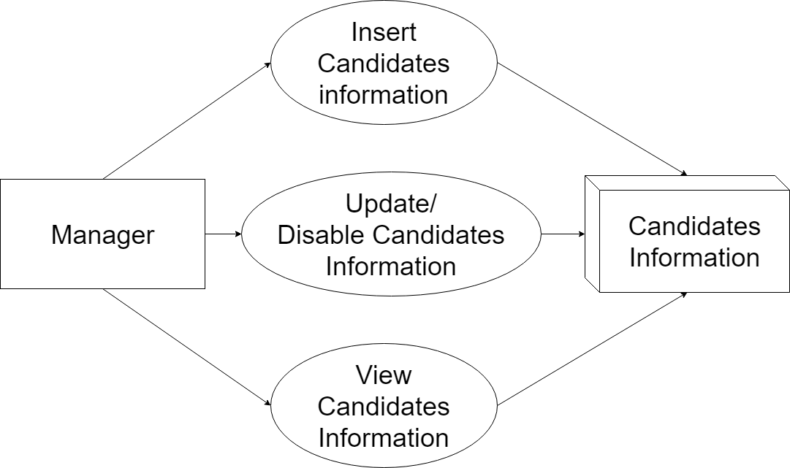

### *2.3. Manager Manage Exam Registrations*

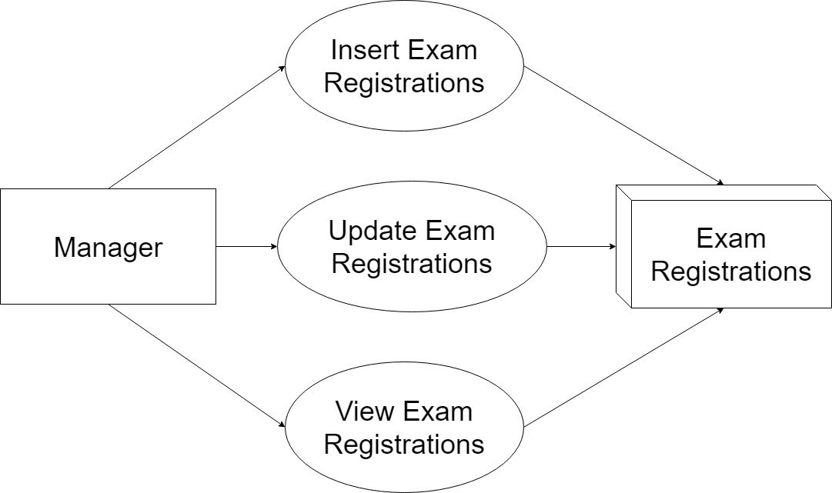

### *2.4. Manager Manage Schedule*

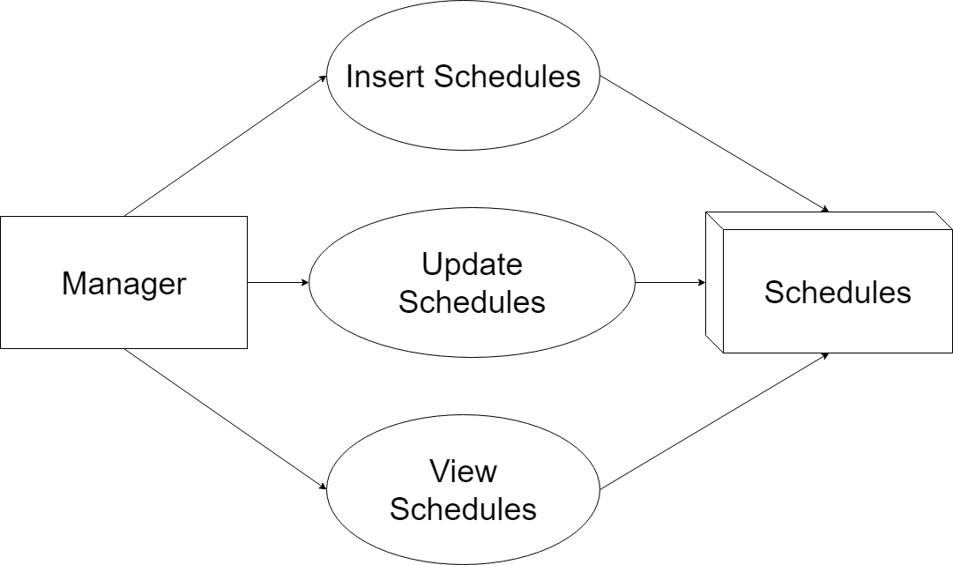

### *2.5. Manager Manage Exam Result*

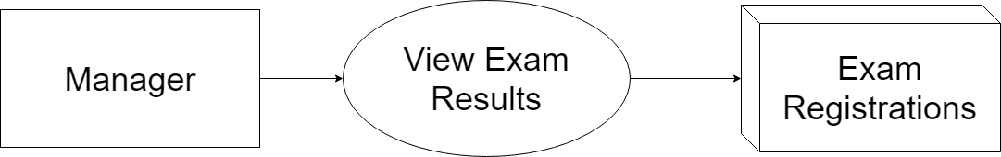

### *2.6. Manager Manage Questions*

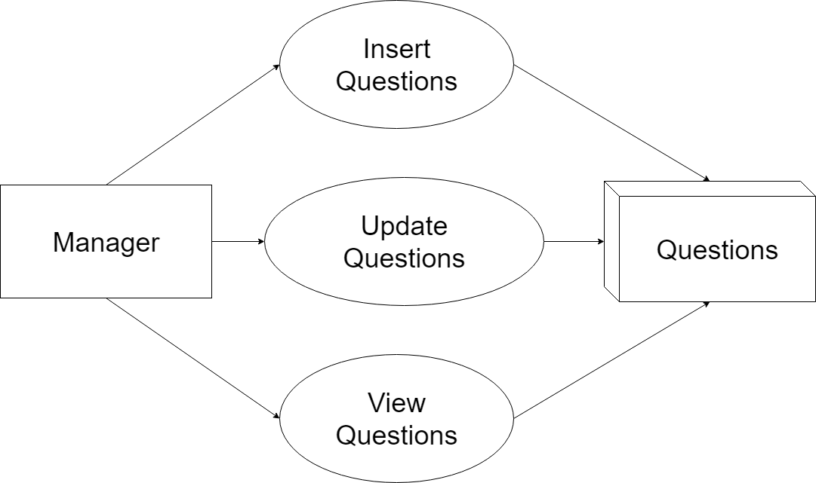

### *2.7. Manager Manage Questions Type*

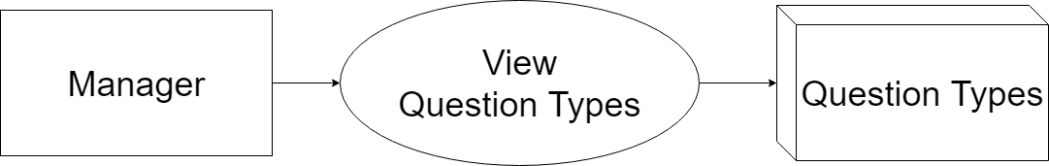

### *2.8. Candidate Manage Candidates Information*

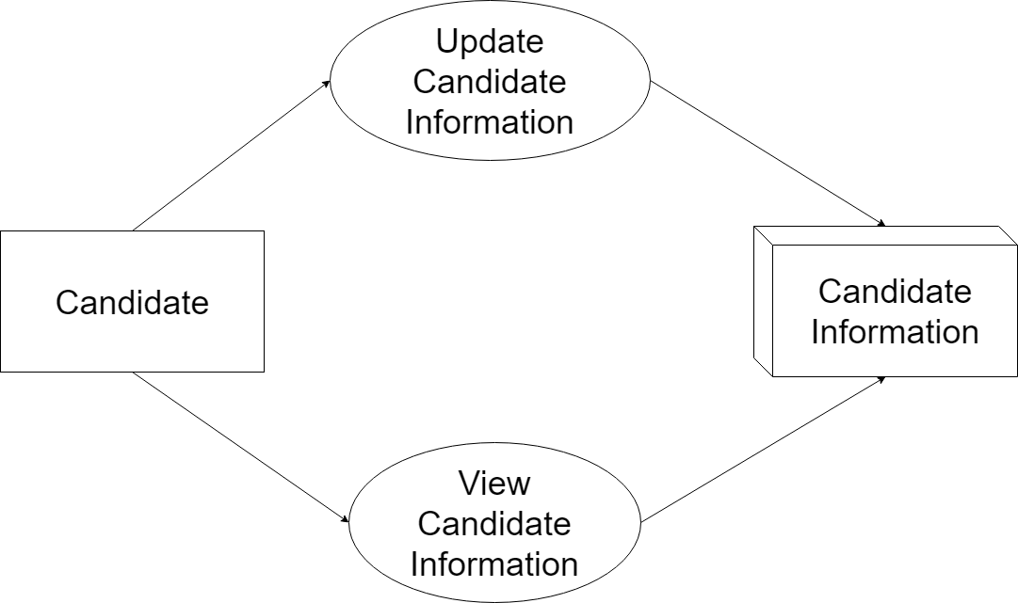

### *2.9. Candidate Manage Test Registrations*

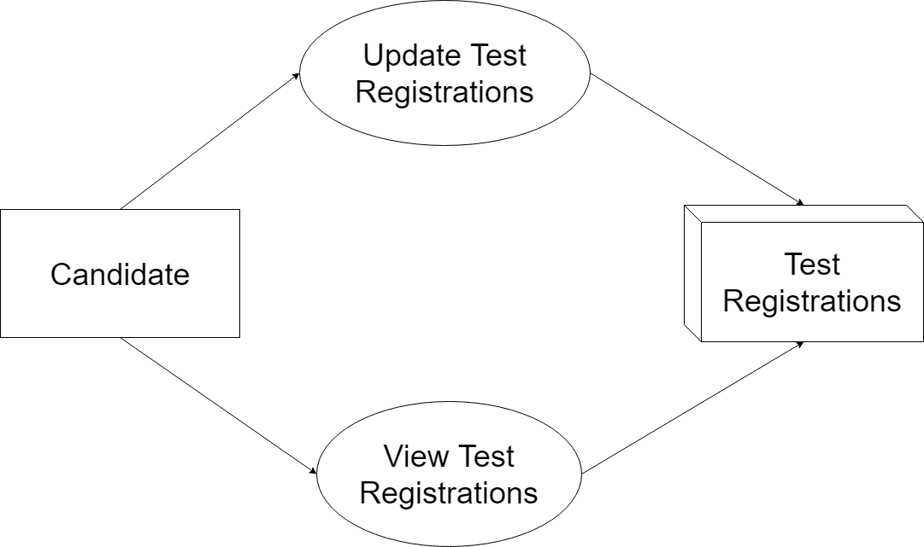

### *2.10. Candidate Manage Schedules*

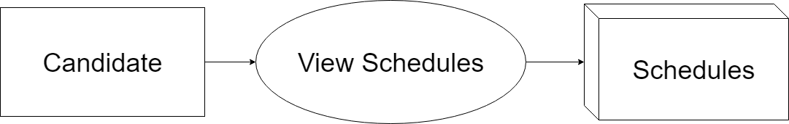

### *2.11. Candidate Manage Test Result*

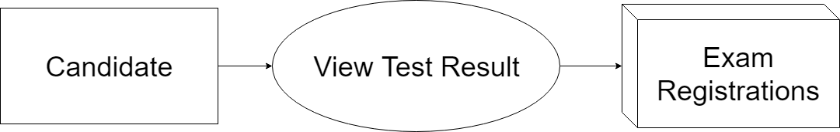

# VII. Use Case Diagram:

***1. Administrator Use Case***

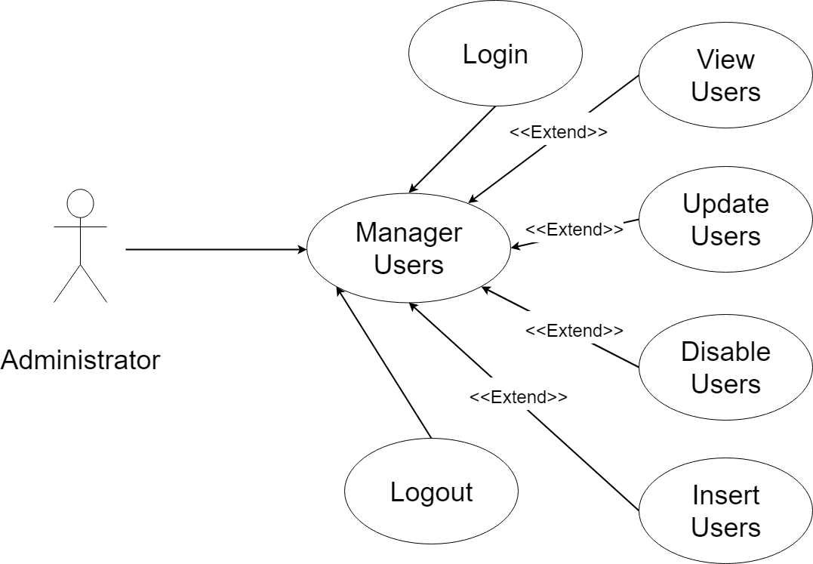

## 2. Manager Use Case

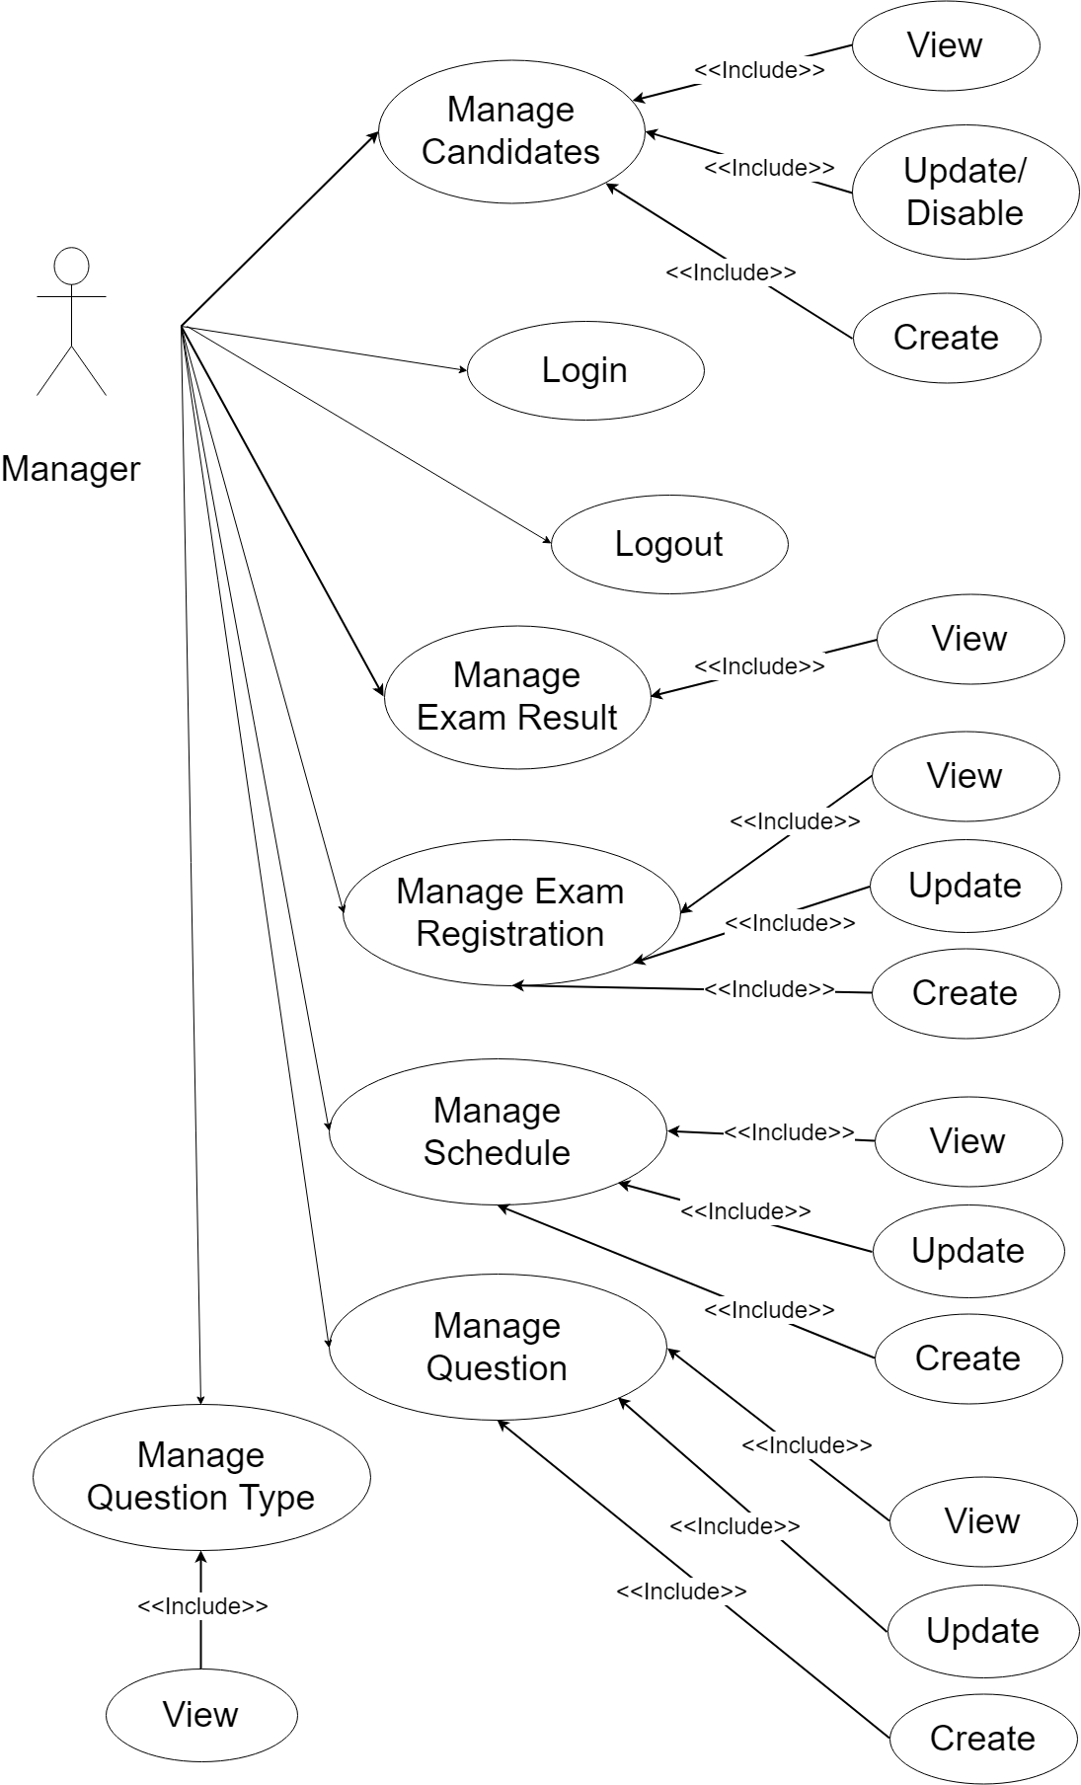

## 3. Candidate Use Case

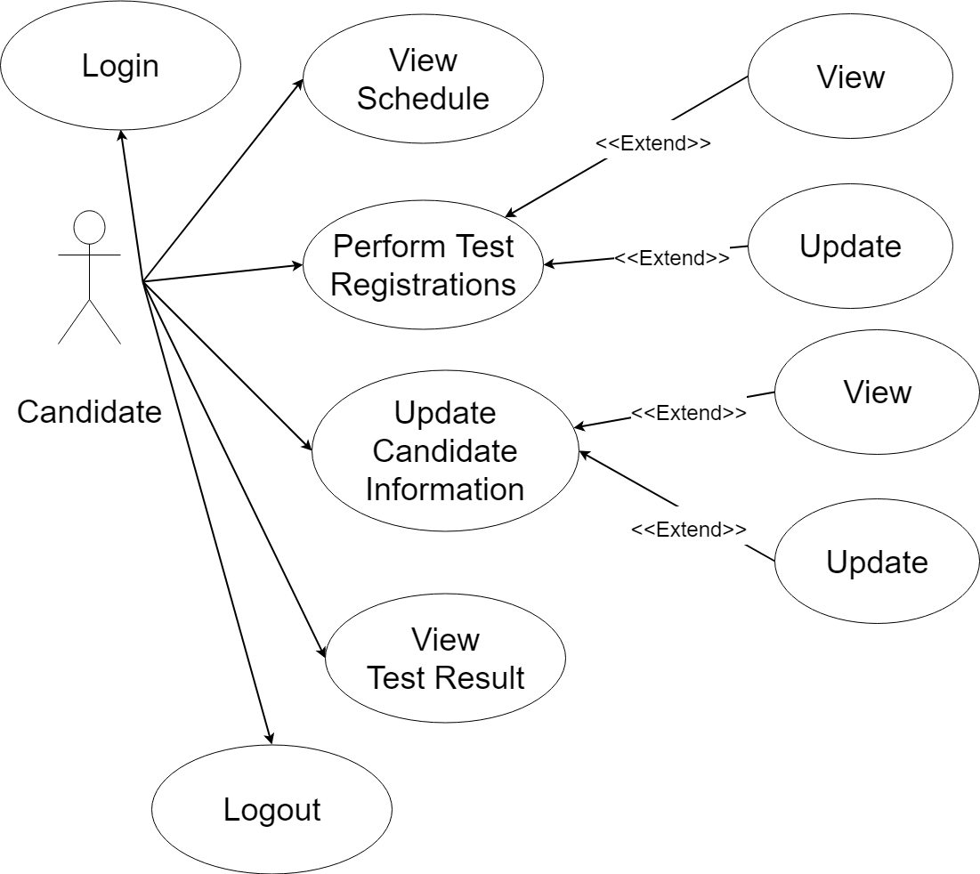

# VIII. Sequence Diagram:

1. ***Create User***

Use Case Description

|  |  |  |  |
| --- | --- | --- | --- |
| Name | Create user |  |  |
| Description | Allow admin to create new account. | | |
| Actor | Amin | Trigger | Click create a new Account on pages. |
| Pre-condition | Admin login to the system. | | |
| Post condition | Create a new account. | | |

Activities

|  |  |  |  |
| --- | --- | --- | --- |
| Actor | | System | |
| Main Flow: Load Home admin clear page is successful | | | |
| 1 | Click a Manage Account and choose Create a new account. |  |  |
|  |  | 2 | Display textbox to enter information. |
| 3 | Enter complete information for the space. Click the submit Create. |  |  |
|  |  | 4 | Confirmation of accounts on the system. |

Business Rules

|  |  |  |
| --- | --- | --- |
| Rule No. | Rule | Description |
| 1 | Enter complete information | When creating new account must complete the information required system. |

System Message

|  |  |
| --- | --- |
| MS01 | Create new account success. |
| MS02 | Enter complete information |

1. ***Update/Disable User***

Use Case Description

|  |  |  |  |
| --- | --- | --- | --- |
| Name | Update/Disable User |  |  |
| Description | Allow admin to update account. | | |
| Actor | Admin, | Trigger | When user click update user |
| Pre-condition | User must login into the system. | | |
| Post condition |  | | |

Activities

|  |  |  |  |
| --- | --- | --- | --- |
| Actor | | System | |
| Main Flow: Display statistics about CP is successful | | | |
| 1 | User fill out the required information on the form changes and click on save button. |  |  |
|  |  | 2 | Check the data on the form and update to database. |
| 3 | Click button back |  |  |
|  |  | 4 | The system updates the user to quit. |

Business Rules

|  |  |  |
| --- | --- | --- |
| Rule No. | Rule | Description |
|  |  |  |
|  |  |  |
|  |  |  |
|  |  |  |
|  |  |  |

System Message

|  |  |
| --- | --- |
| MS01 | Do you want to update your information? |
| MS02 | Update successful! |
| MS03 | Do you want to exit this page? |

1. ***View User***

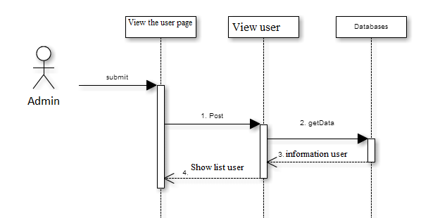

Use Case Description

|  |  |  |  |
| --- | --- | --- | --- |
| Name | View user |  |  |
| Description | Allow admin see list user | | |
| Actor | Admin | Trigger | Click View user on menu. |
| Pre-condition | You must login system with admin rights | | |
| Post condition |  | | |

Activities:

|  |  |  |  |
| --- | --- | --- | --- |
| Actor | | System | |
| Main Flow: View notify for leaves successfully | | | |
| 1 | Click show list user on menu |  |  |
|  |  | 2 | Displays a list of user on page |

1. ***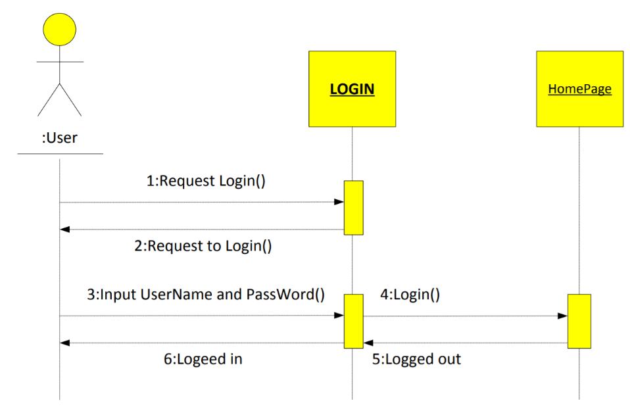******Login:***

Use Case Description:

|  |  |  |  |
| --- | --- | --- | --- |
| Name | Login |  |  |
| Description | Allows users to log into the system | | |
| Users | Admin, candidates, Managers | Trigger |  |
| Pre-condition |  | | |
| Post condition | Go to the login page except home page | | |

Activities:

|  |  |  |  |
| --- | --- | --- | --- |
| Actor | | System | |
| Main Flow: Load Home admin clear page is successful | | | |
| 1 | Click a Manage Account and choose Create a new account. |  |  |
|  |  | 2 | Display textbox to enter information. |
| 3 | Enter complete information for the space. Click the submit Create. |  |  |
|  |  | 4 | Confirmation of accounts on the system. |

Business Rules:

|  |  |  |
| --- | --- | --- |
| Rule No. | Rule | Description |
| 1 |  | Display error message box account and password.  Input password in a state of no data |
| 2 |  | If ( username and password are true) login is successfully. |

System Message:

|  |  |
| --- | --- |
| MS01 | “Wrong Username”  Notice in the page display.  “Wrong Password”  Notice in the page display. |

1. ***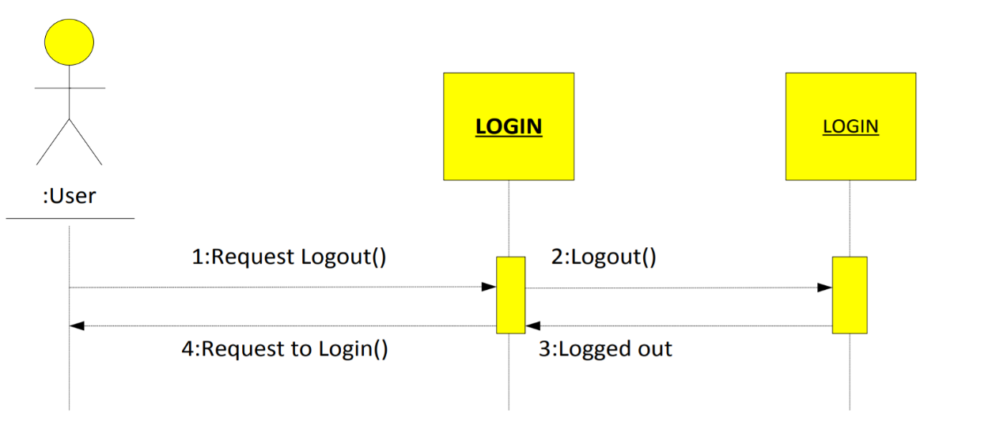******Logout:***

Use Case Description:

|  |  |  |  |
| --- | --- | --- | --- |
| Name | Logout |  |  |
| Description | Allow user log off the system | | |
| Users | Admin, candidates, Manager | Trigger | When user click the logout button on the page. |
| Pre-condition | User must login into the system. | | |
| Post condition | Return to login | | |

Activities:

|  |  |  |  |
| --- | --- | --- | --- |
| Actor | | System | |
| Main Flow: Login successfully | | | |
| 1 | User click logout. |  |  |
|  |  | 2 | Return login. |

Business Rules:

|  |  |  |
| --- | --- | --- |
| Rule No. | Rule | Description |
| 1 |  | Click logout when they return to login. |

System Message:

|  |  |
| --- | --- |
| MS01 | Show successfully singed informed |

1. ***Change password***

Use Case Description

|  |  |  |  |
| --- | --- | --- | --- |
| Name | Change password |  |  |
| Description | Allow user to change password | | |
| Actor | Admin, Candidates, Manager | Trigger | Click change password on this page. |
| Pre-condition | User must login on the system. | | |
| Post condition |  | | |

Activities:

|  |  |  |  |
| --- | --- | --- | --- |
| Actor | | System | |
| Main Flow: View notify for leaves successfully | | | |
| 1 | Click change password on menu. |  |  |
|  |  | 2 | Redirected to change password. |
| 3 | Enter information. |  |  |
|  |  | 4 | Change password on database |
| 5 | Click back button. |  |  |
|  |  | 6 | Leaving this page. |

System Message

|  |  |
| --- | --- |
|  | Successful change password. |

1. ***Register user candidates***

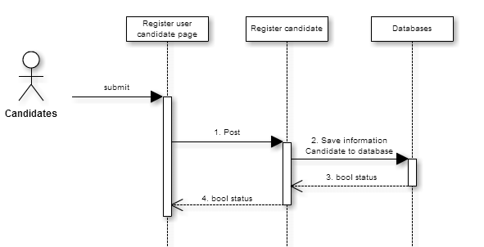

Use Case Description:

|  |  |  |  |
| --- | --- | --- | --- |
| Name | Register user candidates |  |  |
| Description | Allows candidates to register an account | | |
| Actor | Candidates | Trigger | Click register on schedules page. |
| Pre-condition |  | | |
| Post condition |  | | |

Activities:

|  |  |  |  |  |
| --- | --- | --- | --- | --- |
| Actor | | System | | |
| Main Flow: View notify for leaves successfully | | | | |
| 1 | Click register on schedules page. | |  |  |
|  |  | | 2 | Redirect new candidates page |
| 3 | Enter information and click save. | |  |  |
|  |  | | 4 | Save candidate information and redirect schedules page |

1. ***Manager register user candidates***

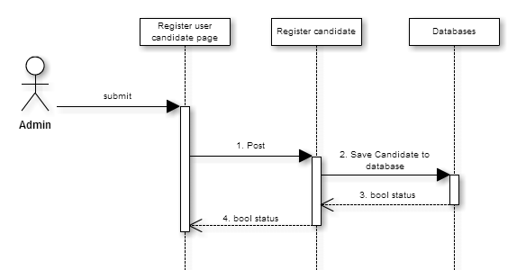

Use Case Description:

|  |  |  |  |
| --- | --- | --- | --- |
| Name | Manage register user candidates |  |  |
| Description | Allow admin to manage register user candidates | | |
| Actor | Manager | Trigger | Click manage candidates on admin page. |
| Pre-condition | You must login system with admin rights | | |
| Post condition |  | | |

Activities:

|  |  |  |  |
| --- | --- | --- | --- |
| Actor | | System | |
| Main Flow: View notify for leaves successfully | | | |
| 1 | Click manage register on menu |  |  |
|  |  | 2 | Displays a list of registers on page |
| 3 | Click register |  |  |
|  |  | 4 | Redirect new candidate page |
| 5 | Enter information and click save. |  |  |
|  |  | 6 | Save candidate information and redirect management register |

1. ***Manage questions***

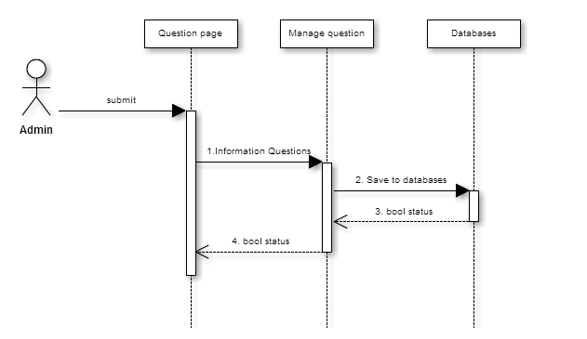

Use Case Description

|  |  |  |  |
| --- | --- | --- | --- |
| Name | Manage Question |  |  |
| Description | Allow admin to manage questions | | |
| Actor | Manager | Trigger | Click manage question on admin page. |
| Pre-condition | You must login system with admin rights | | |
| Post condition |  | | |

Activities:

|  |  |  |  |
| --- | --- | --- | --- |
| Actor | | System | |
| Main Flow: View notify for leaves successfully | | | |
| 1 | Click manage questions on menu |  |  |
|  |  | 2 | Displays a list of questions on page |
| 3 | Click new question |  |  |
|  |  | 4 | Redirect new question page |
| 5 | Enter information and click save. |  |  |
|  |  | 6 | Save the question and redirect management questions |
| 5 | Click update button. |  |  |
|  |  | 6 | Redirect update question page |
| 7 | Enter information and click save. |  |  |

1. ***Manage schedule***

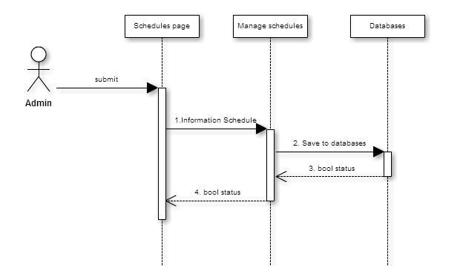

Use Case Description:

|  |  |  |  |
| --- | --- | --- | --- |
| Name | Manage schedule |  |  |
| Description | Allow admin to manage schedule | | |
| Actor | Manager | Trigger | Click manage schedule on admin page. |
| Pre-condition | You must login system with admin rights | | |
| Post condition |  | | |

Activities:

|  |  |  |  |
| --- | --- | --- | --- |
| Actor | | System | |
| Main Flow: View notify for leaves successfully | | | |
| 1 | Click manage schedules on menu |  |  |
|  |  | 2 | Displays a list of schedule on page |
| 3 | Click new schedules |  |  |
|  |  | 4 | Redirect new schedule page |
| 5 | Enter information and click save. |  |  |
|  |  | 6 | Save the schedule and redirect management schedules |
| 5 | Click update button. |  |  |
|  |  | 6 | Redirect update schedule page |
| 7 | Enter information and click save. |  |  |
|  |  | 8 | Save the schedule and redirect management schedules |

1. ***Manage exam***

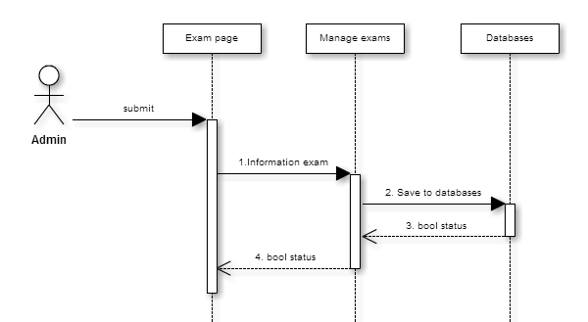

Use Case Description

|  |  |  |  |
| --- | --- | --- | --- |
| Name | Manage Exam |  |  |
| Description | Allow admin to manage exams | | |
| Actor | Manager | Trigger | Click manage exams on admin page. |
| Pre-condition | You must login system with admin rights | | |
| Post condition |  | | |

Activities:

|  |  |  |  |
| --- | --- | --- | --- |
| Actor | | System | |
| Main Flow: View notify for leaves successfully | | | |
| 1 | Click manage exams on menu |  |  |
|  |  | 2 | Displays a list of exams on page |
| 3 | Click new exam |  |  |
|  |  | 4 | Redirect new exam page |
| 5 | Enter information and click save. |  |  |
|  |  | 6 | Save the exam and redirect management exams |
| 5 | Click update button. |  |  |
|  |  | 6 | Redirect update exam page |
| 7 | Enter information and click save. |  |  |
|  |  | 8 | Save the exam and redirect management exams |

1. ***Manage test results***

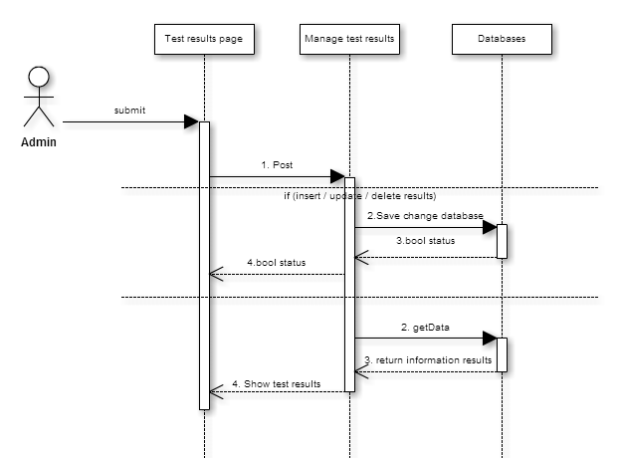

Use Case Description

|  |  |  |  |
| --- | --- | --- | --- |
| Name | Manage Test Results |  |  |
| Description | Allow admin to manage Test Results | | |
| Actor | Manager | Trigger | Click manage result on admin page. |
| Pre-condition | You must login system with admin rights | | |
| Post condition |  | | |

Activities:

|  |  |  |  |
| --- | --- | --- | --- |
| Actor | | System | |
| Main Flow: View notify for leaves successfully | | | |
| 1 | Click manage result on menu |  |  |
|  |  | 2 | Displays a list of result on page |
| 3 | Enter information and click save. |  |  |
|  |  | 4 | Save the result and redirect management result |
| 5 | Click update button. |  |  |
|  |  | 6 | Redirect result question page |
| 7 | Enter information and click save. |  |  |
|  |  | 8 | Save the result and redirect management result |

1. ***View the schedule***

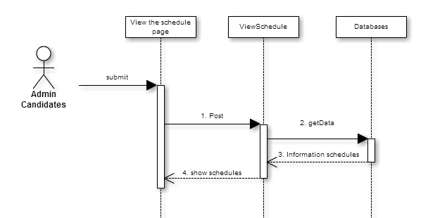

Use Case Description

|  |  |  |  |
| --- | --- | --- | --- |
| Name | View the schedules |  |  |
| Description | Allow user view the schedules | | |
| Actor | Manager, Candidate | Trigger | Click schedules on menu |
| Pre-condition |  | | |
| Post condition |  | | |

Activities:

|  |  |  |  |
| --- | --- | --- | --- |
| Actor | | System | |
| Main Flow: View notify for leaves successfully | | | |
| 1 | Click schedules on menu |  |  |
|  |  | 2 | Displays a list of schedules on page |

1. ***View results***

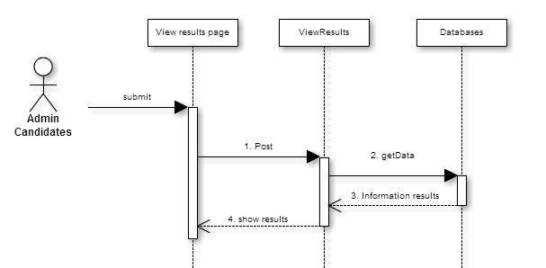

Use Case Description

|  |  |  |  |
| --- | --- | --- | --- |
| Name | View results |  |  |
| Description | Allow candidates see test results | | |
| Actor | Candidates | Trigger | Click View results on candidates page. |
| Pre-condition | You must login system with candidate rights | | |
| Post condition |  | | |

Activities:

|  |  |  |  |
| --- | --- | --- | --- |
| Actor | | System | |
| Main Flow: View notify for leaves successfully | | | |
| 1 | Click show results on menu |  |  |
|  |  | 2 | Displays a list of results on page |

1. ***Perform test***

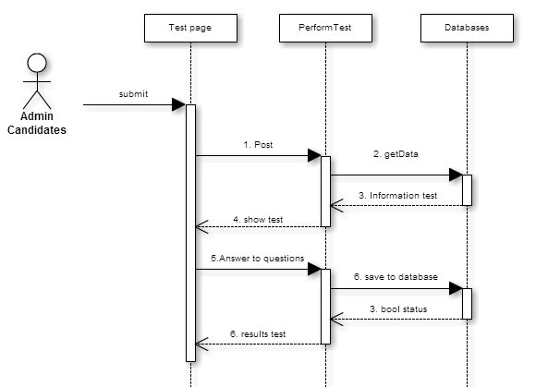

Use Case Description

|  |  |  |  |
| --- | --- | --- | --- |
| Name | Perform test |  |  |
| Description | Allow candidate exam | | |
| Actor | Candidates | Trigger | Click Perform test on this page. |
| Pre-condition | User must login on the system. | | |
| Post condition |  | | |

Activities:

|  |  |  |  |
| --- | --- | --- | --- |
| Actor | | System | |
| Main Flow: View notify for leaves successfully | | | |
| 1 | Click Perform test on menu. |  |  |
|  |  | 2 | Redirected General Knowledge test page |
| 3 | Enter information and click next. |  |  |
|  |  | 4 | Redirected Mathematics test page |
| 5 | Enter information and click next. |  |  |
|  |  | 6 | Redirected Computer Technology test page |
| 7 | Enter information and click finished |  |  |
|  |  | 8 | Take the test information and Redirected result page |
| 9 | Show results |  |  |

# IX. Entity–Relationship Design:

# ***1. Entity–Relationship Diagram***

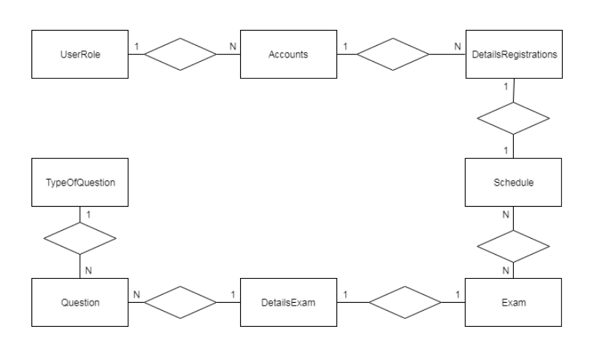

## **2.** Entities and Properties

### *2.1. User Role Entity & Properties*

*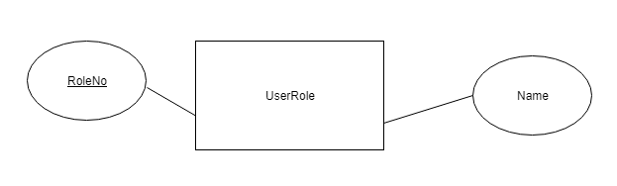2.2 Accounts Entity & Properties*

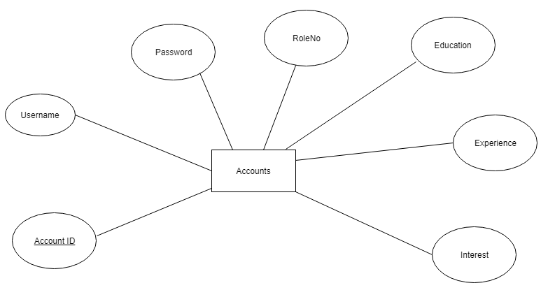

*2.3 Details Registration Entity & Properties*

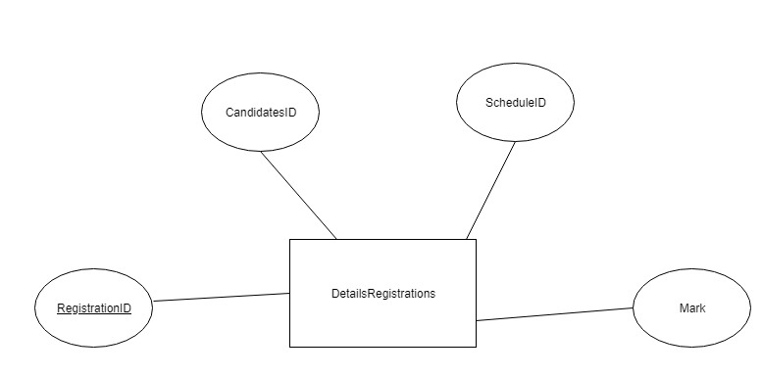

### *2.4 Schedule Entity & Properties*

### 

### *2.5 Exam Entity & Properties*

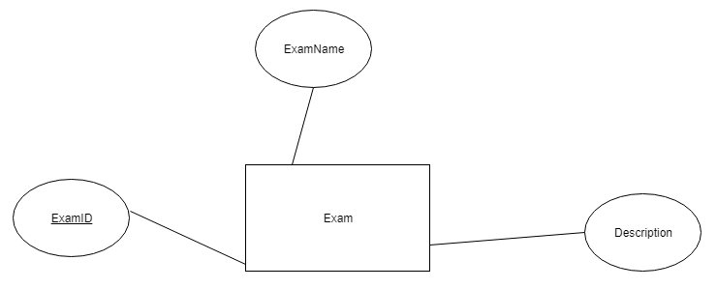

### *2.6 Details Exam Entity & Properties*

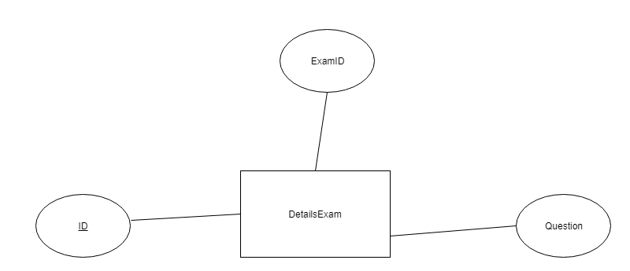

### *2.7 Question Entity & Properties*

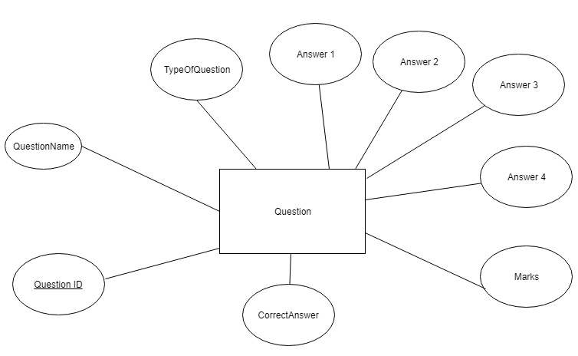

### *2.8 Type Of Question Entity & Properties*

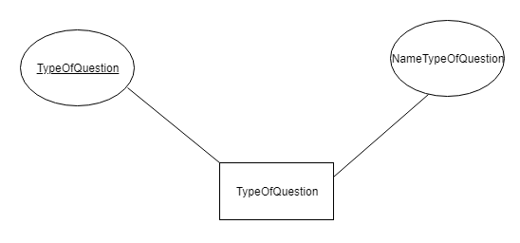

# X. Task sheet review 2

|  |  |  |  |  |
| --- | --- | --- | --- | --- |
| No. | Description | Begin Date | TeamMate Name | Notes |
| 1 | Architecture & Design of the Project | 08/10/2018 | Chi |  |
| 2 | Algorithms - Data Flowchart | Dam |  |
| 3 | Data Flow Diagram | Chi |  |
| 4 | Use Case Diagram | Chi |  |
| 5 | Sequence Diagram | Dam |  |
| 6 | Entity–Relationship Design | Quan |  |
|  |  |  |  |  |

|  |  |
| --- | --- |
| Date: | |
| **Signature of Instructor:**  **Dinh Vu Quoc Trung** | **Signature of Team Leader:**  **To Nguyen Thien Chi** |